**CLOUD COMPUTING LAB**



**Submitted By: Zunaira Khatoon**

**Submitted To: Engr. Muhammad Shoaib**

**Roll No: BSE-2023-074**

**Section: V-B**

***LAB 10***

Contents

**Task 1: GH CLI installation, authentication, Codespaces (in Codespace)** 2

**Task 2: AWS CLI install/configure, Terraform install & verify, create main.tf provider block** 5

A. Install AWS CLI (Skip if already installed) 5

B. Install Terraform CLI 5

C. Provider Configuration (main.tf) 6

**Task 3: VPC/Subnet resource creation via Terraform, verification with CLI filters** 8

**Task 4: Data sources, targeted destroy/refresh/apply, resource tagging** 10

A. Data Source & Resource Creation 10

B. Targeted Destroy & Refresh 11

C. Tagging Resources 14

**Task 5: State file inspection, backup handling, terraform state commands** 17

**Task 6: Terraform output blocks: return values (id, arn, attributes)** 21

**Cleanup: Remove all resources, inspect state files** 23

# [**Task 1: GH CLI installation, authentication, Codespaces (in Codespace)**](https://github.com/WaqasSaleem97/CC_F25/tree/main/Lab_Tasks/Lab_10#task-1--github-cli-codespace-setup-authentication)

1. Install GitHub CLI:

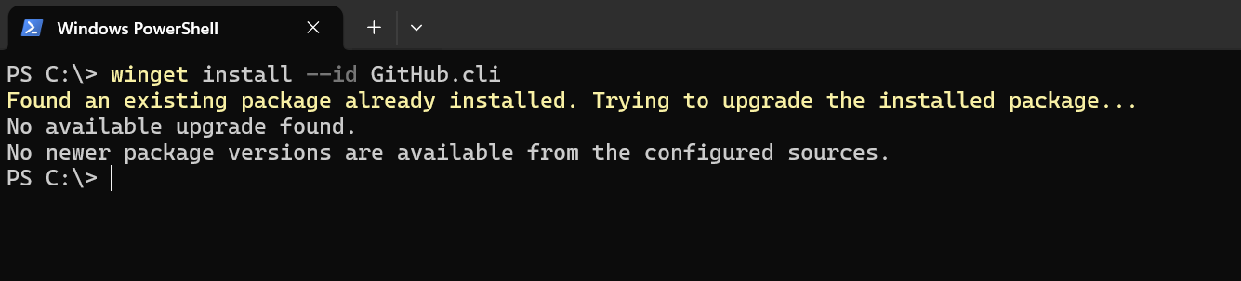

1. Authenticate GH CLI for Codespaces:

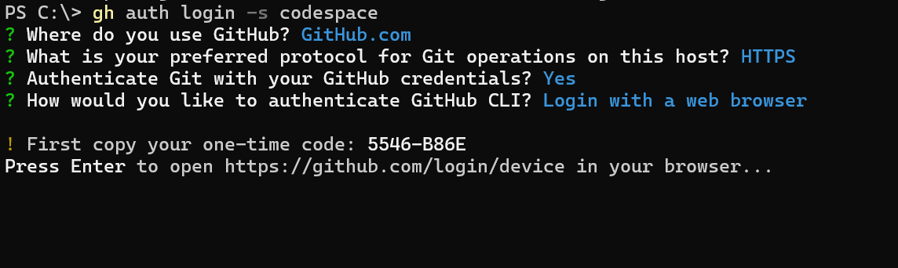

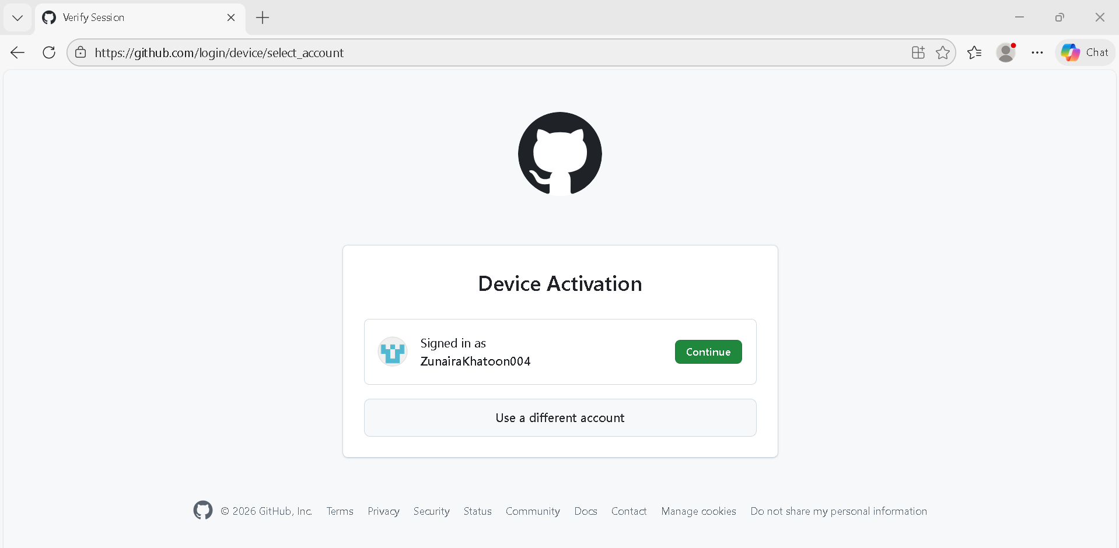

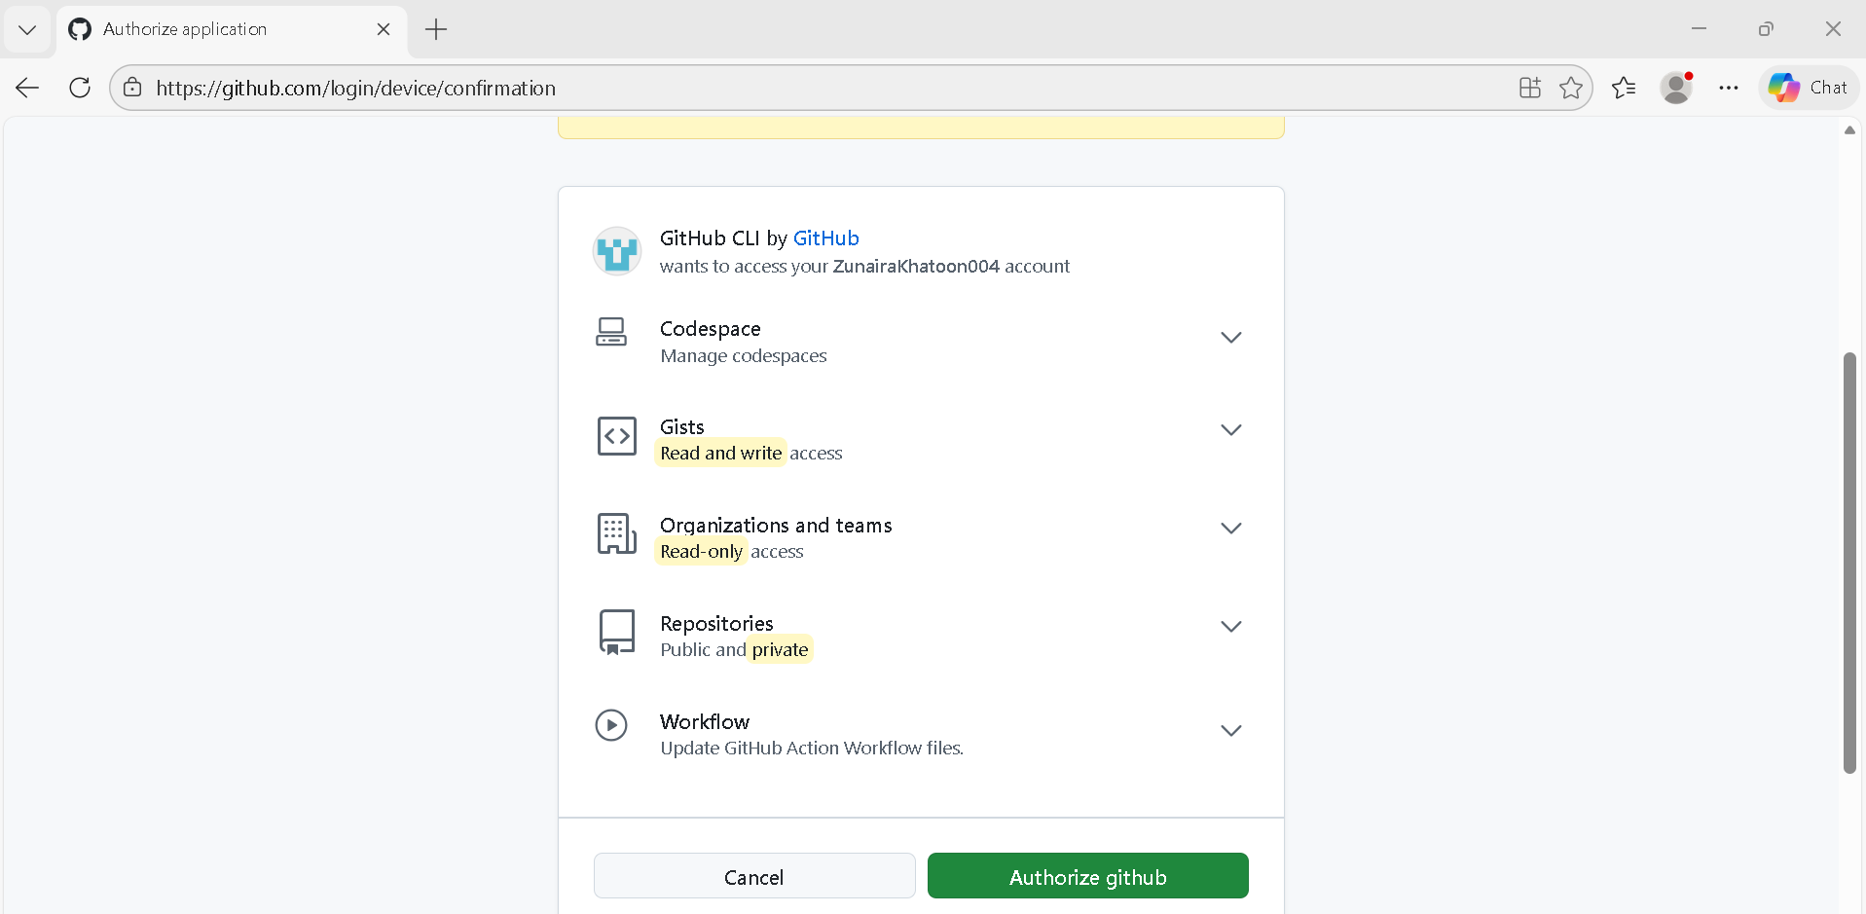

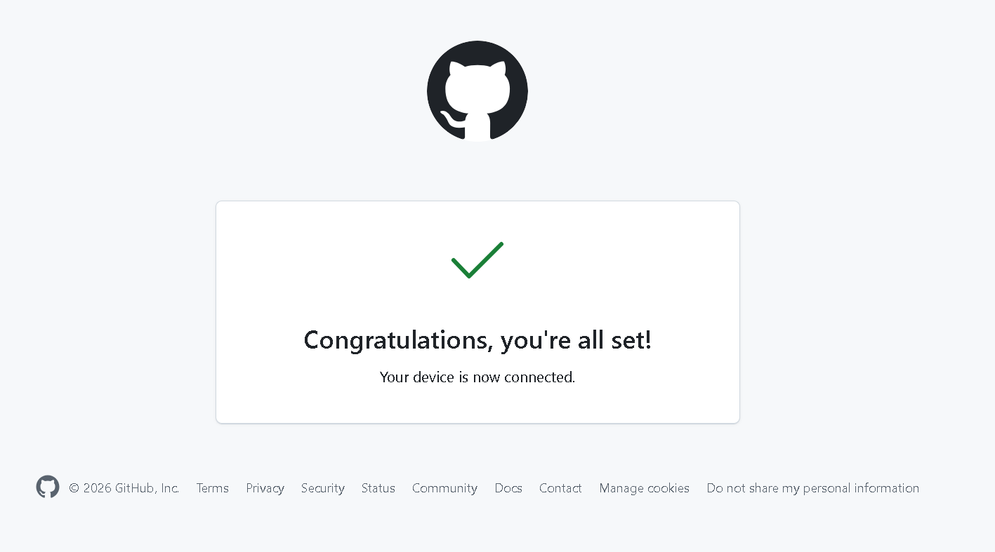

1. List available codespaces:



1. Connect to a codespace via SSH:

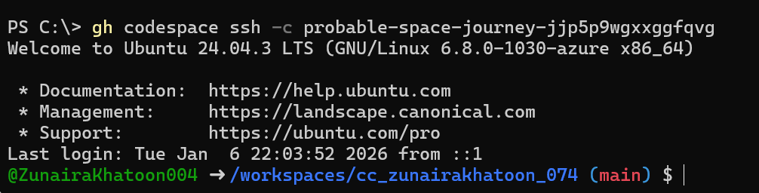

# [**Task 2: AWS CLI install/configure, Terraform install & verify, create main.tf provider block**](https://github.com/WaqasSaleem97/CC_F25/tree/main/Lab_Tasks/Lab_10#task-2--install-aws-cli-terraform-cli-provider-setup)

## A. Install AWS CLI (Skip if already installed)

1. In Codespace shell, install AWS CLI:

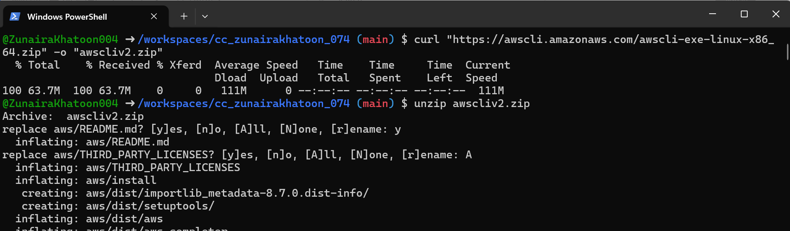

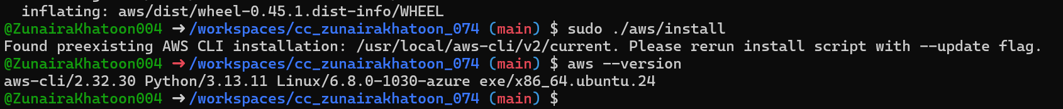

1. Configure AWS CLI:

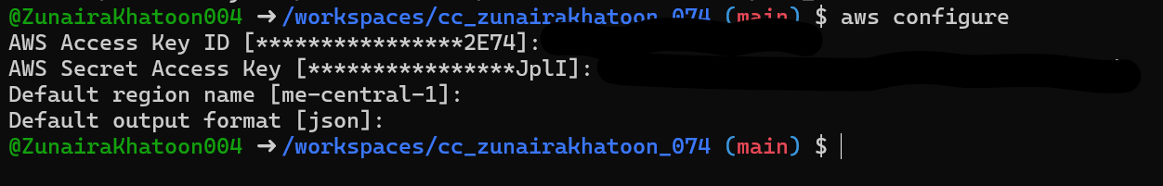

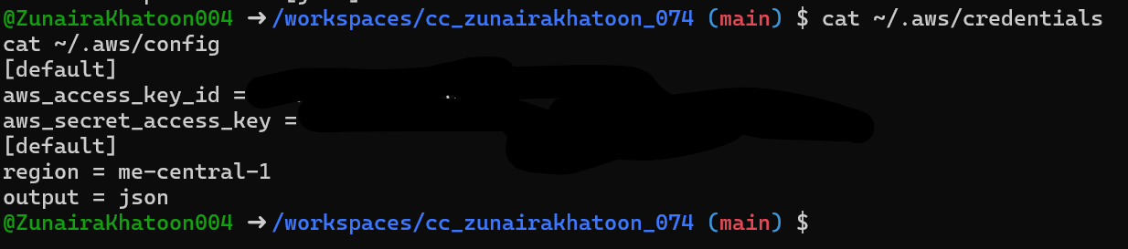

1. Verify AWS CLI connectivity:

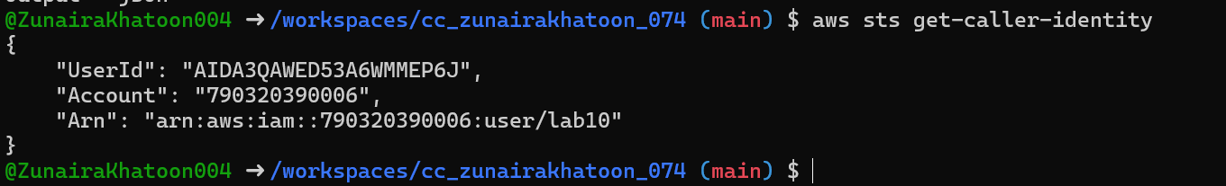

## B. Install Terraform CLI

1. Install Terraform CLI:

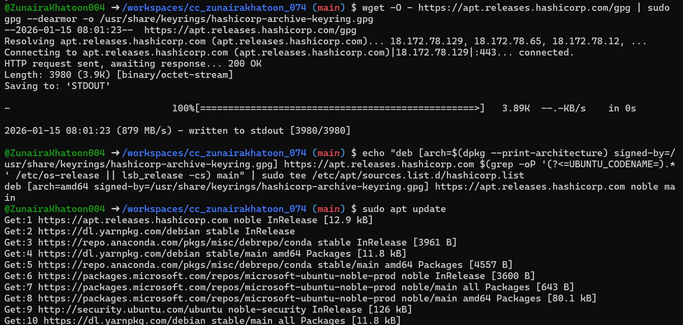

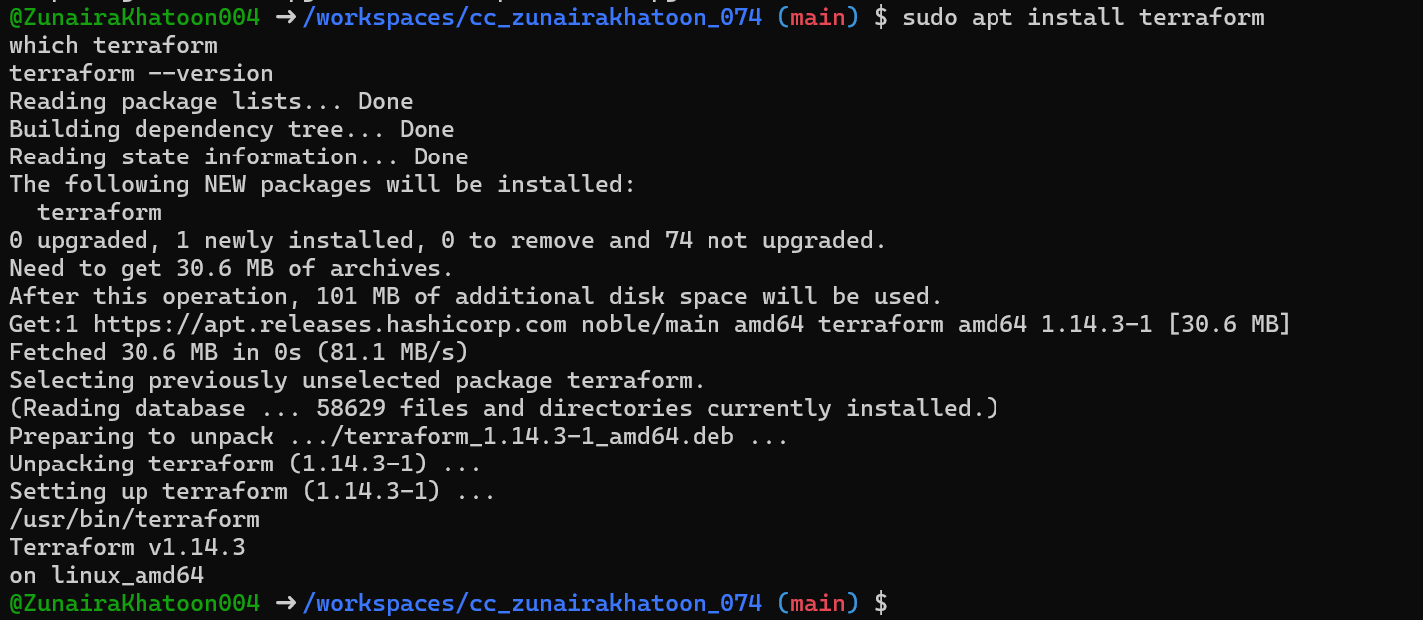

## C. Provider Configuration (main.tf)

* Create main.tf using Vim:



* Inside main.tf, write:

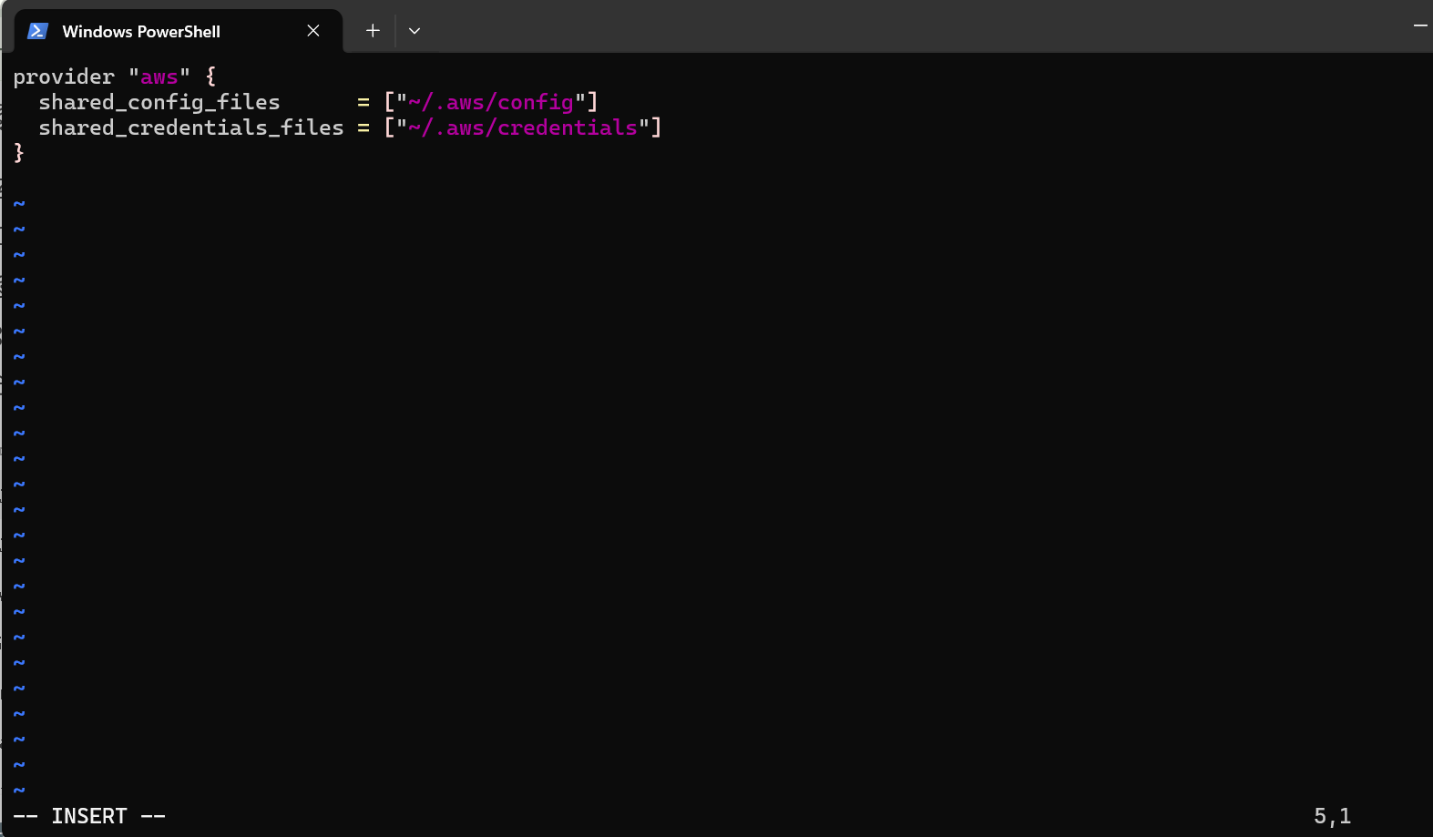

* Save and quit:

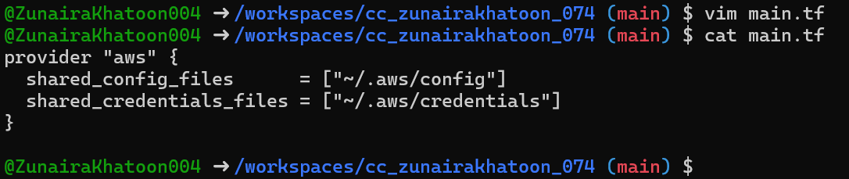

* Initialize Terraform:

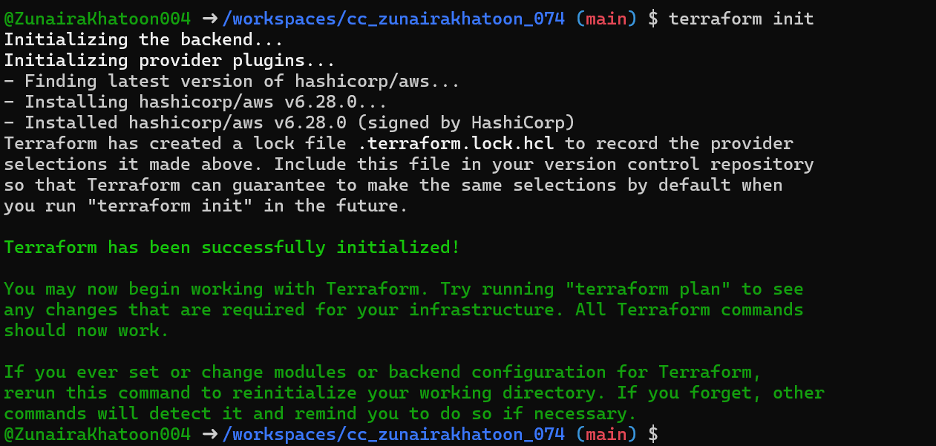

* Show contents of .terraform.lock.hcl:

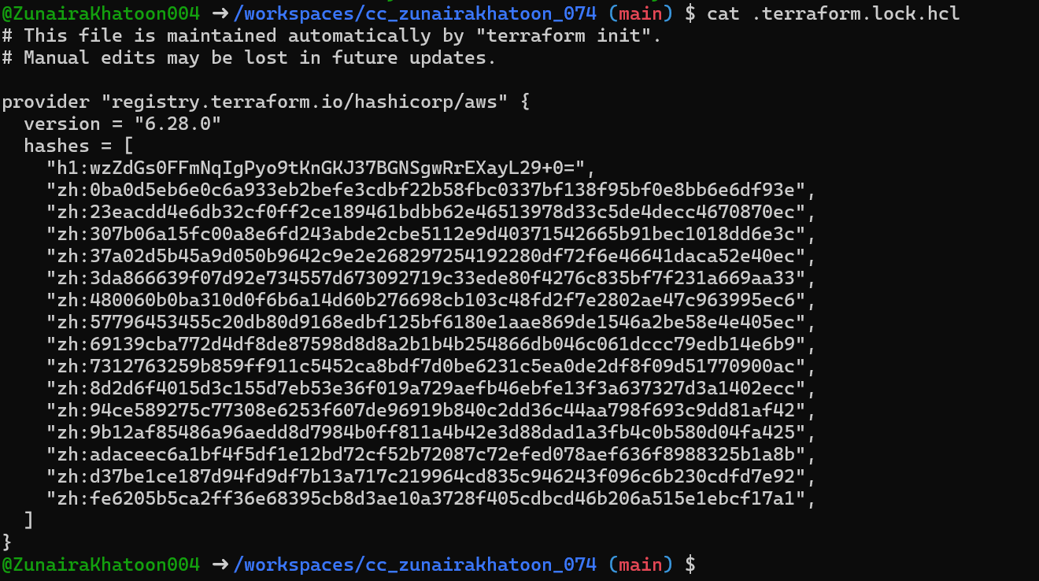

* Show contents of .terraform/ directory:



# [**Task 3: VPC/Subnet resource creation via Terraform, verification with CLI filters**](https://github.com/WaqasSaleem97/CC_F25/tree/main/Lab_Tasks/Lab_10#task-3--vpc-subnet-creation-initialization-verification)

1. Edit main.tf to add:

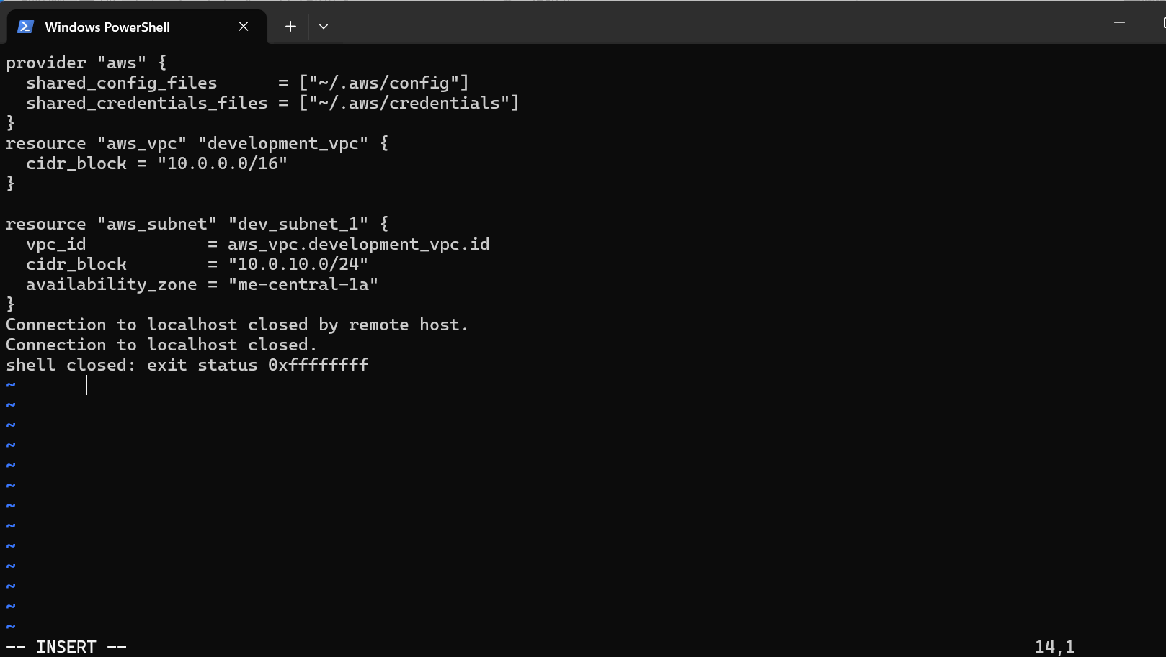

1. Run:

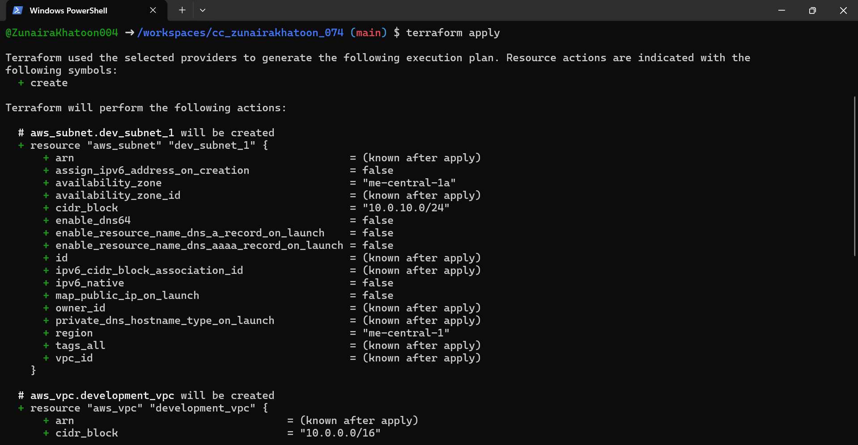

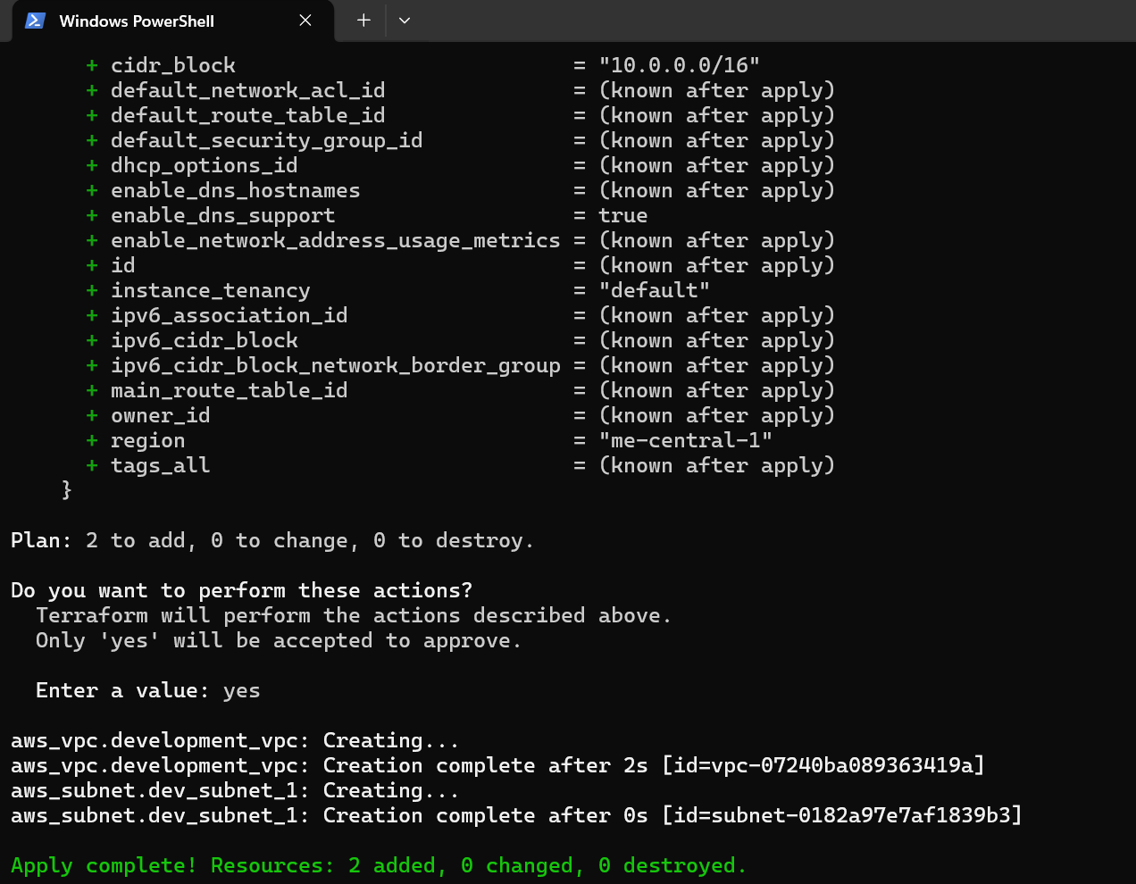

1. Verify resources using AWS CLI:





# [**Task 4: Data sources, targeted destroy/refresh/apply, resource tagging**](https://github.com/WaqasSaleem97/CC_F25/tree/main/Lab_Tasks/Lab_10#task-4--datasource-targeted-destroy-tags)

## A. Data Source & Resource Creation

1. Add to main.tf:

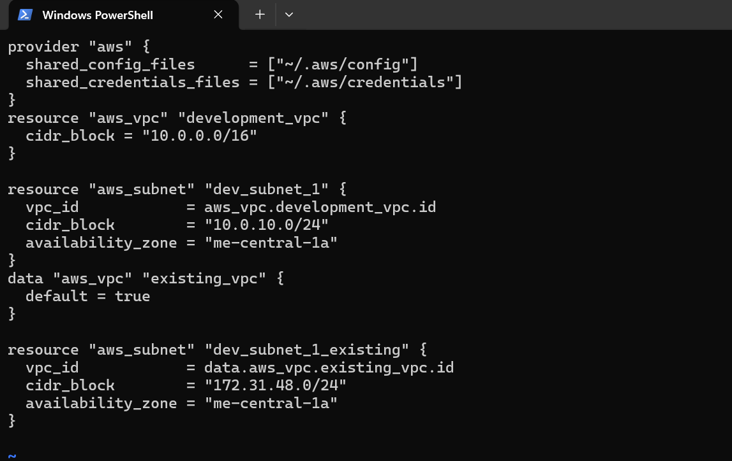

1. Apply configuration:

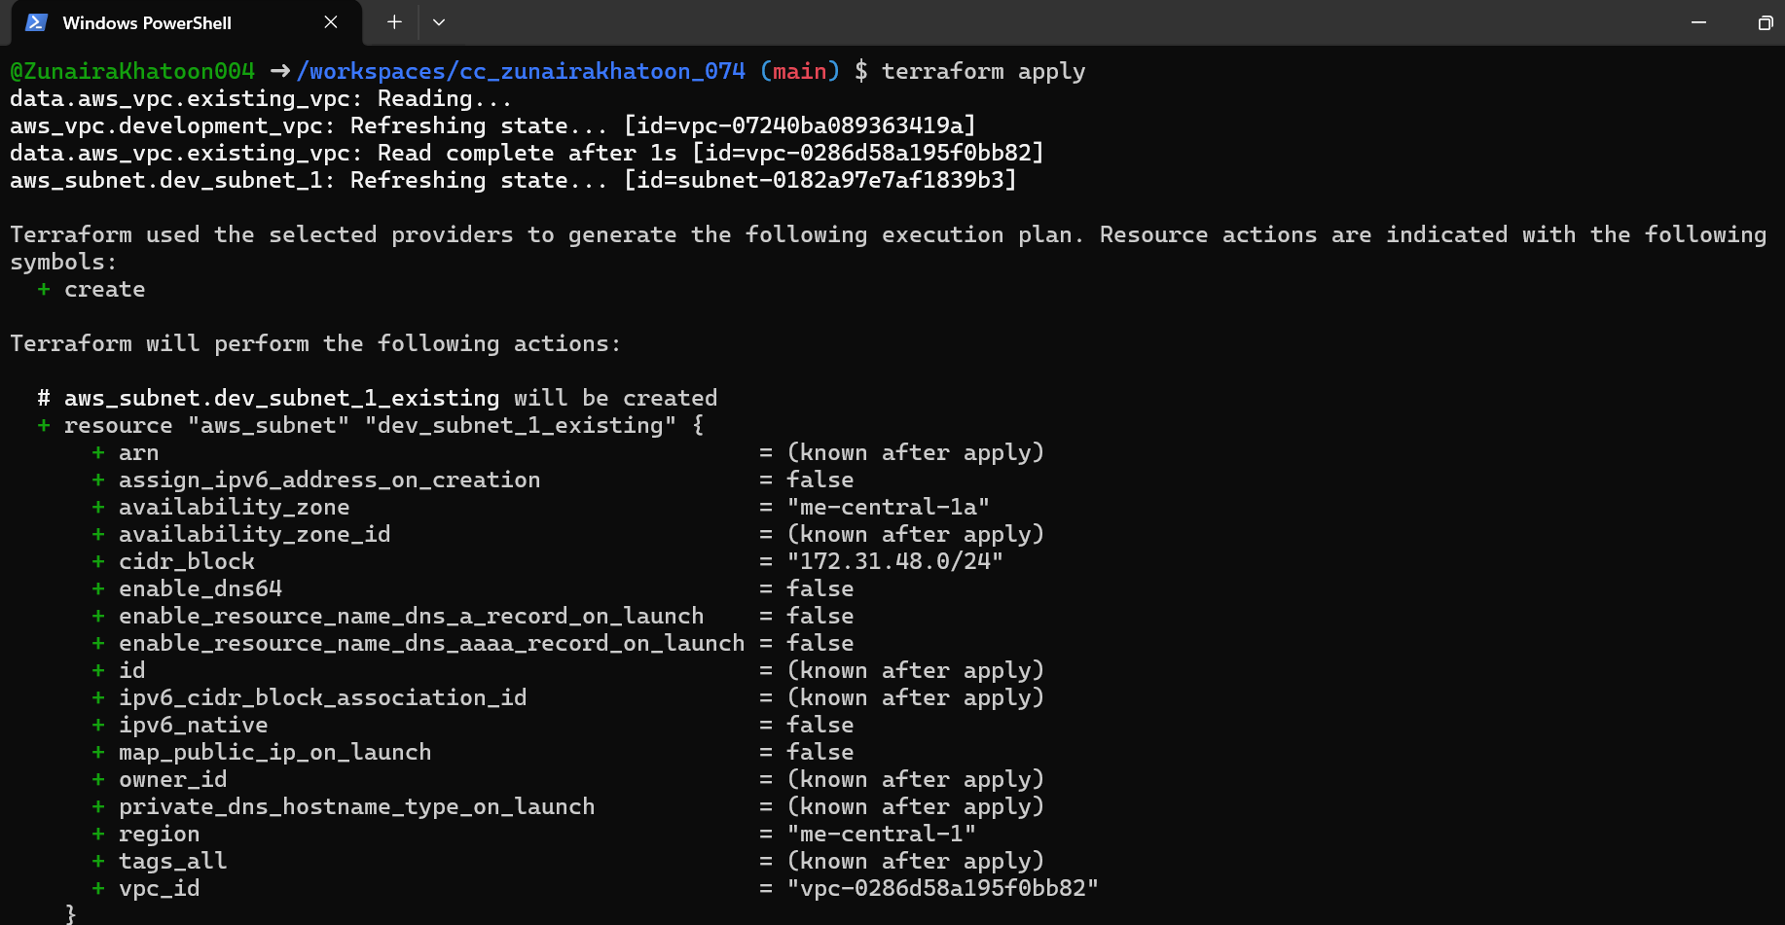

## B. Targeted Destroy & Refresh

1. Destroy only one resource:

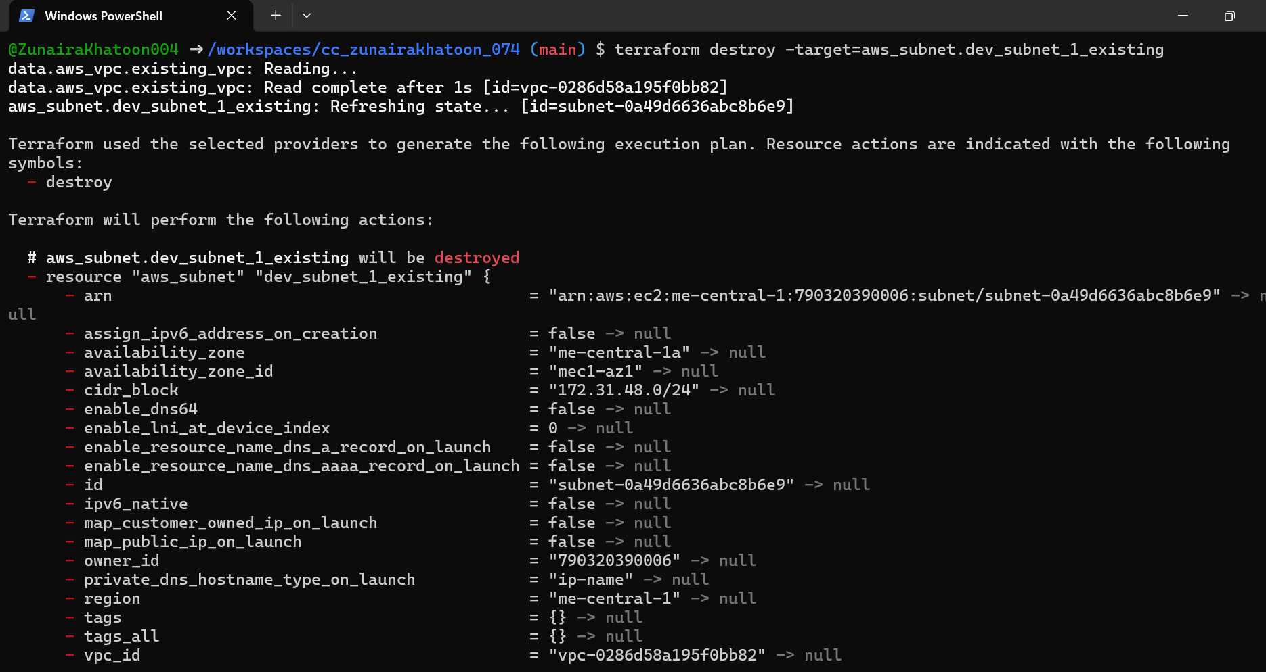

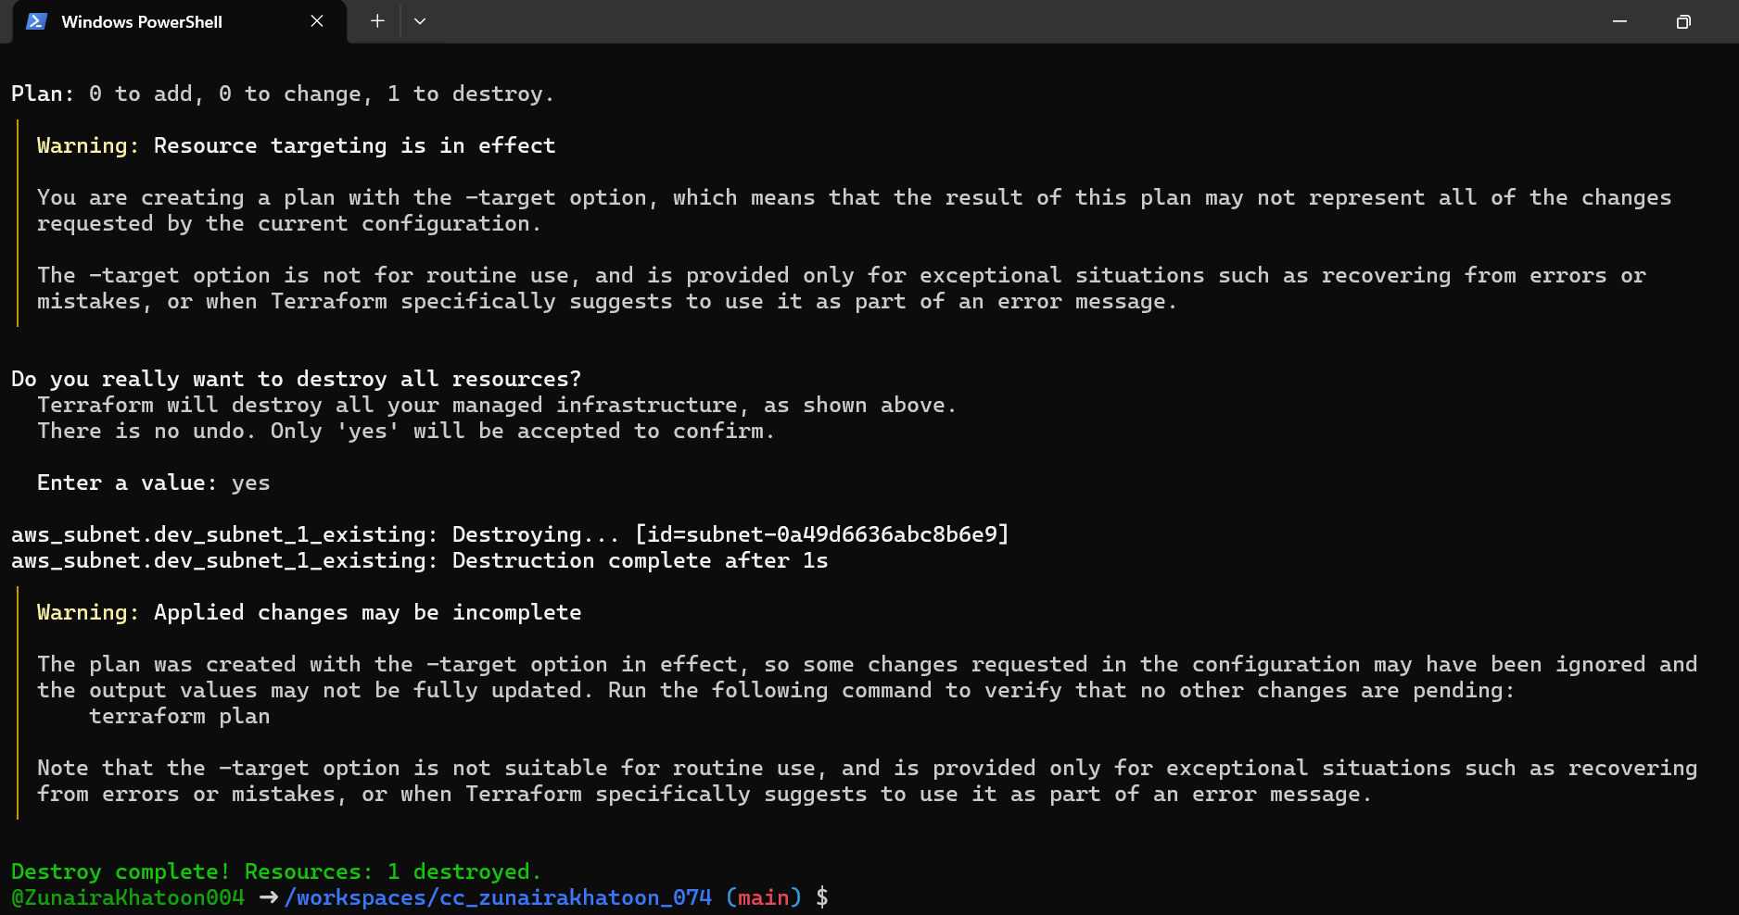

1. Refresh state:

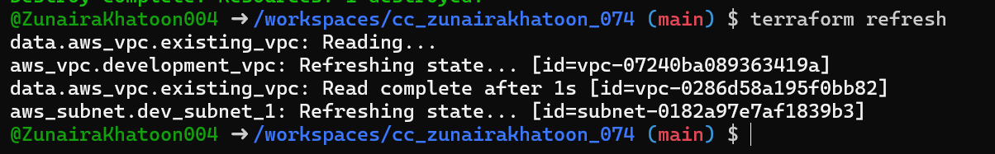

1. Re-apply configuration:

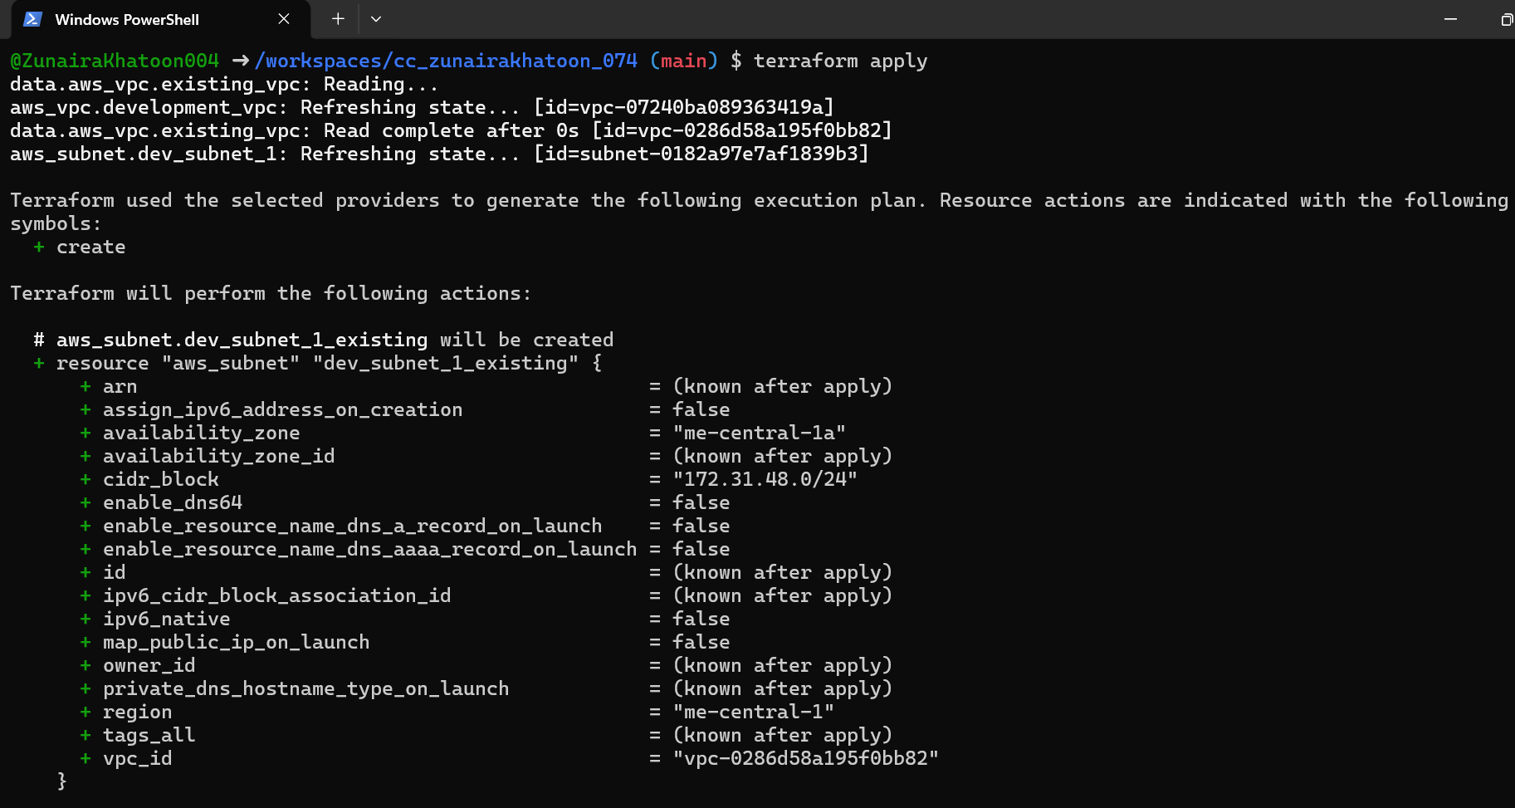

1. Destroy all resources:

Terraform destroy

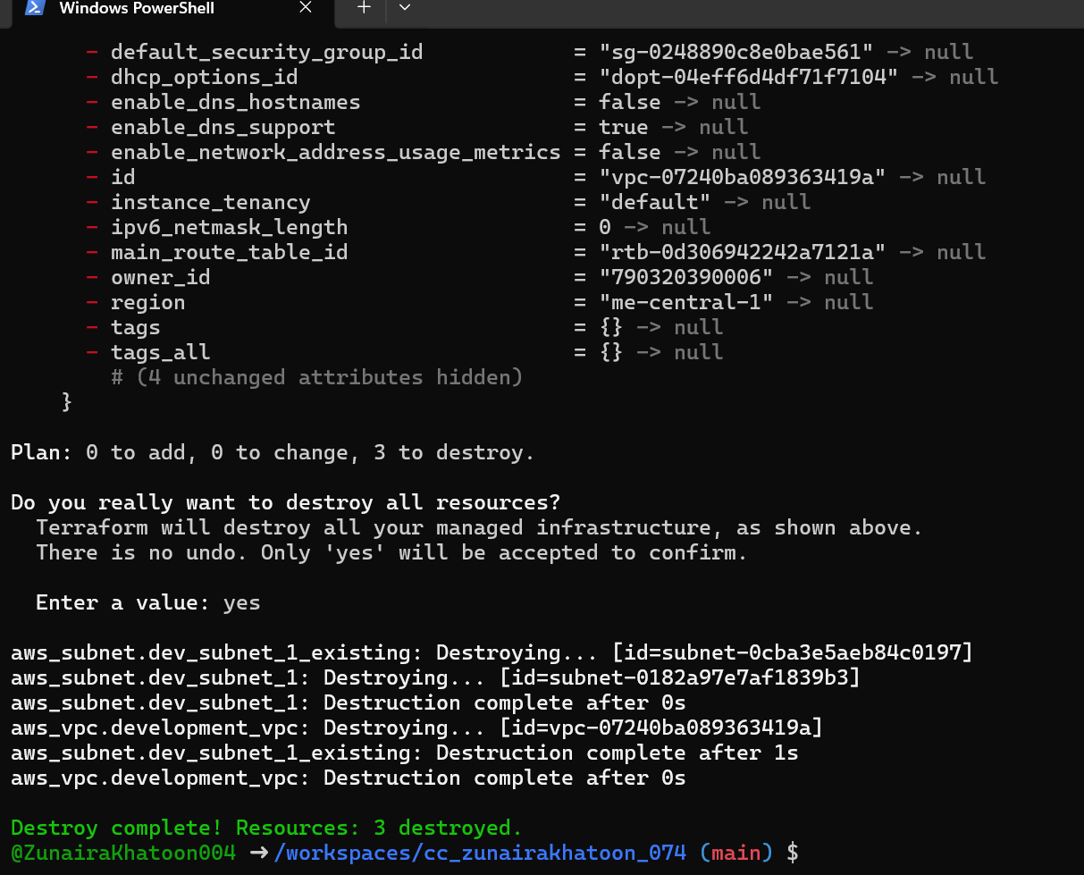

1. Plan configuration:

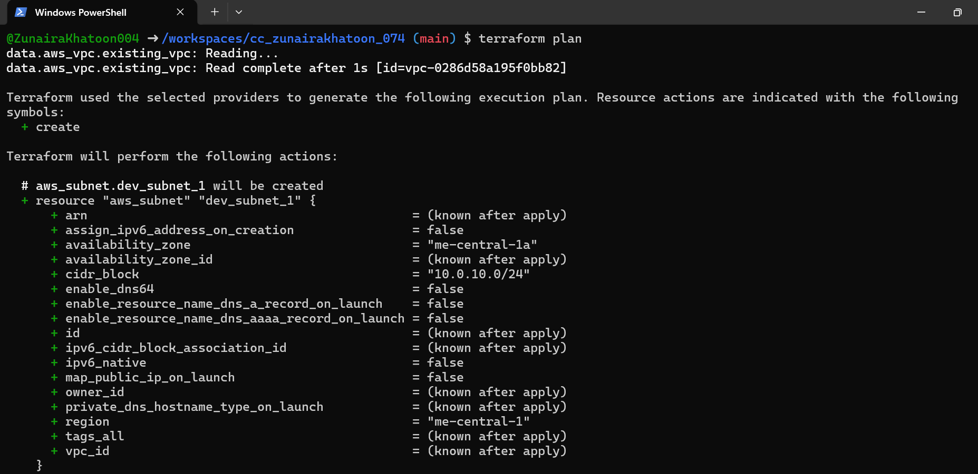

1. Apply again:

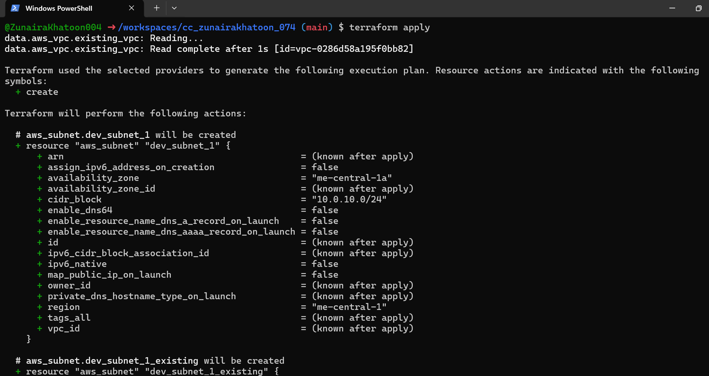

## C. Tagging Resources

1. Modify main.tf to add tags:

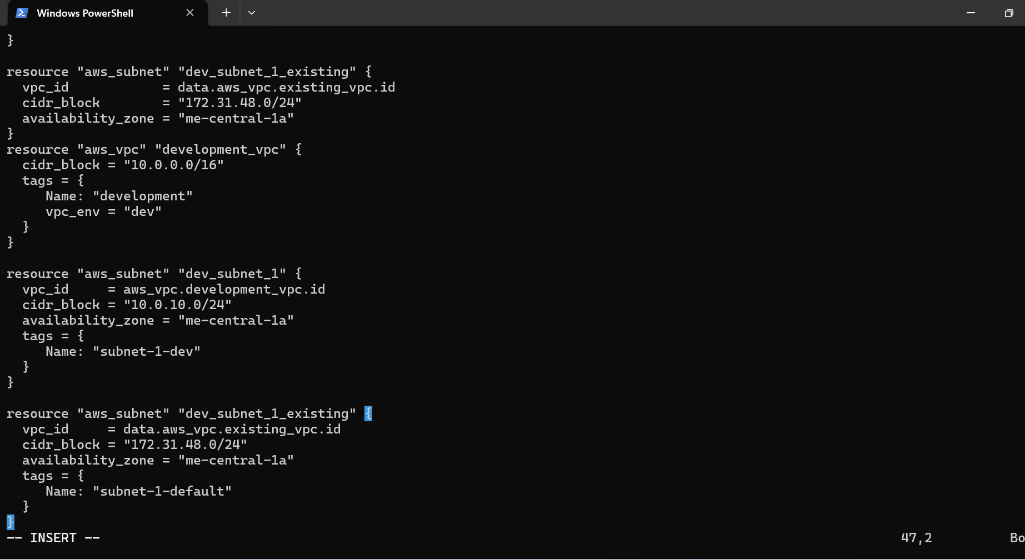

1. Run:

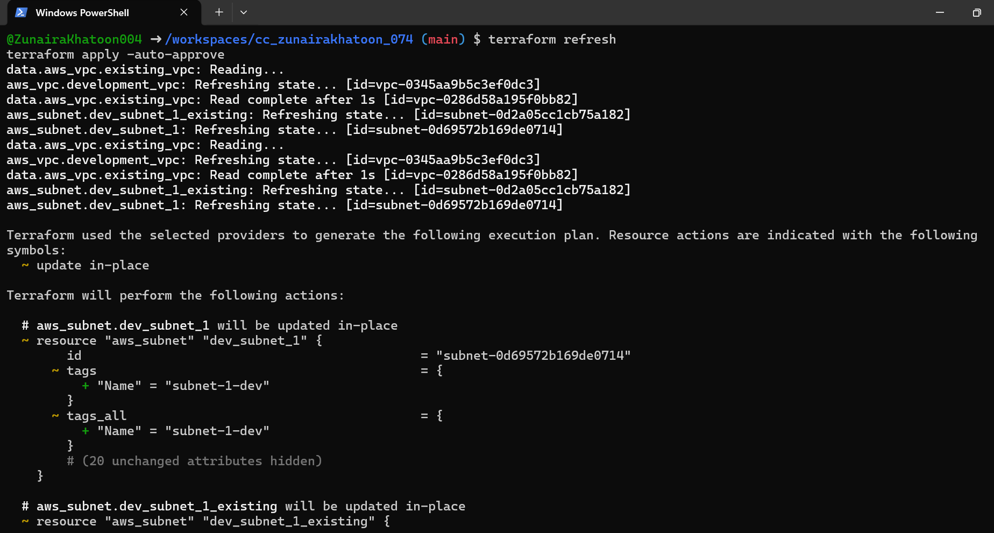

1. Remove vpc_env = "dev" tag from development_vpc resource, re-plan/apply:

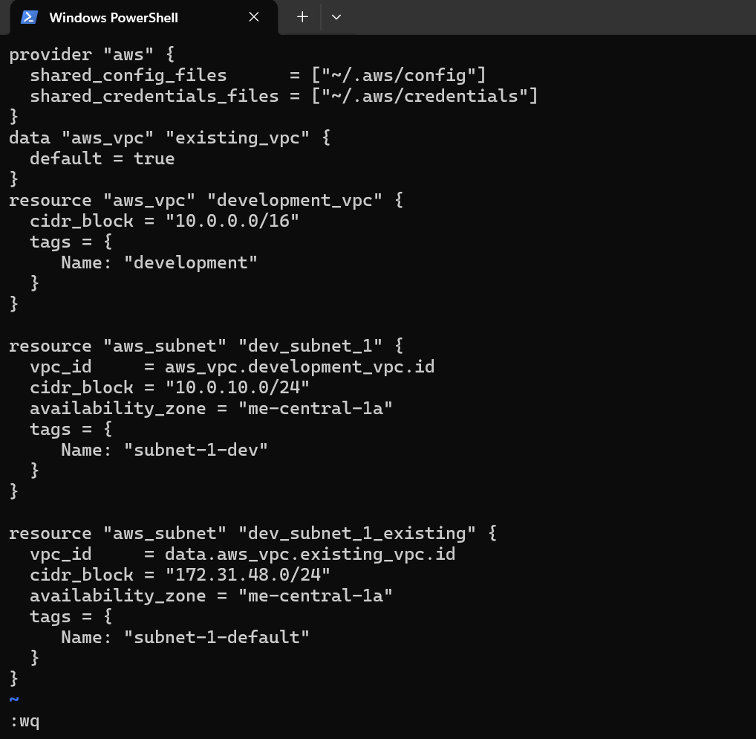

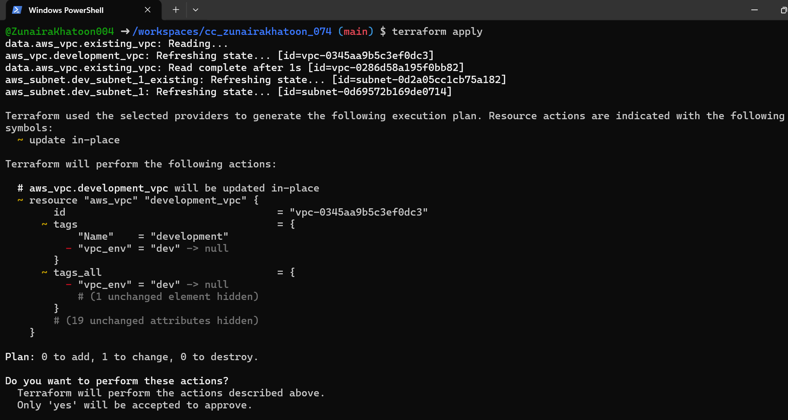

# [**Task 5: State file inspection, backup handling, terraform state commands**](https://github.com/WaqasSaleem97/CC_F25/tree/main/Lab_Tasks/Lab_10#task-5--state-file-inspection-commands)

1. Destroy all resources:

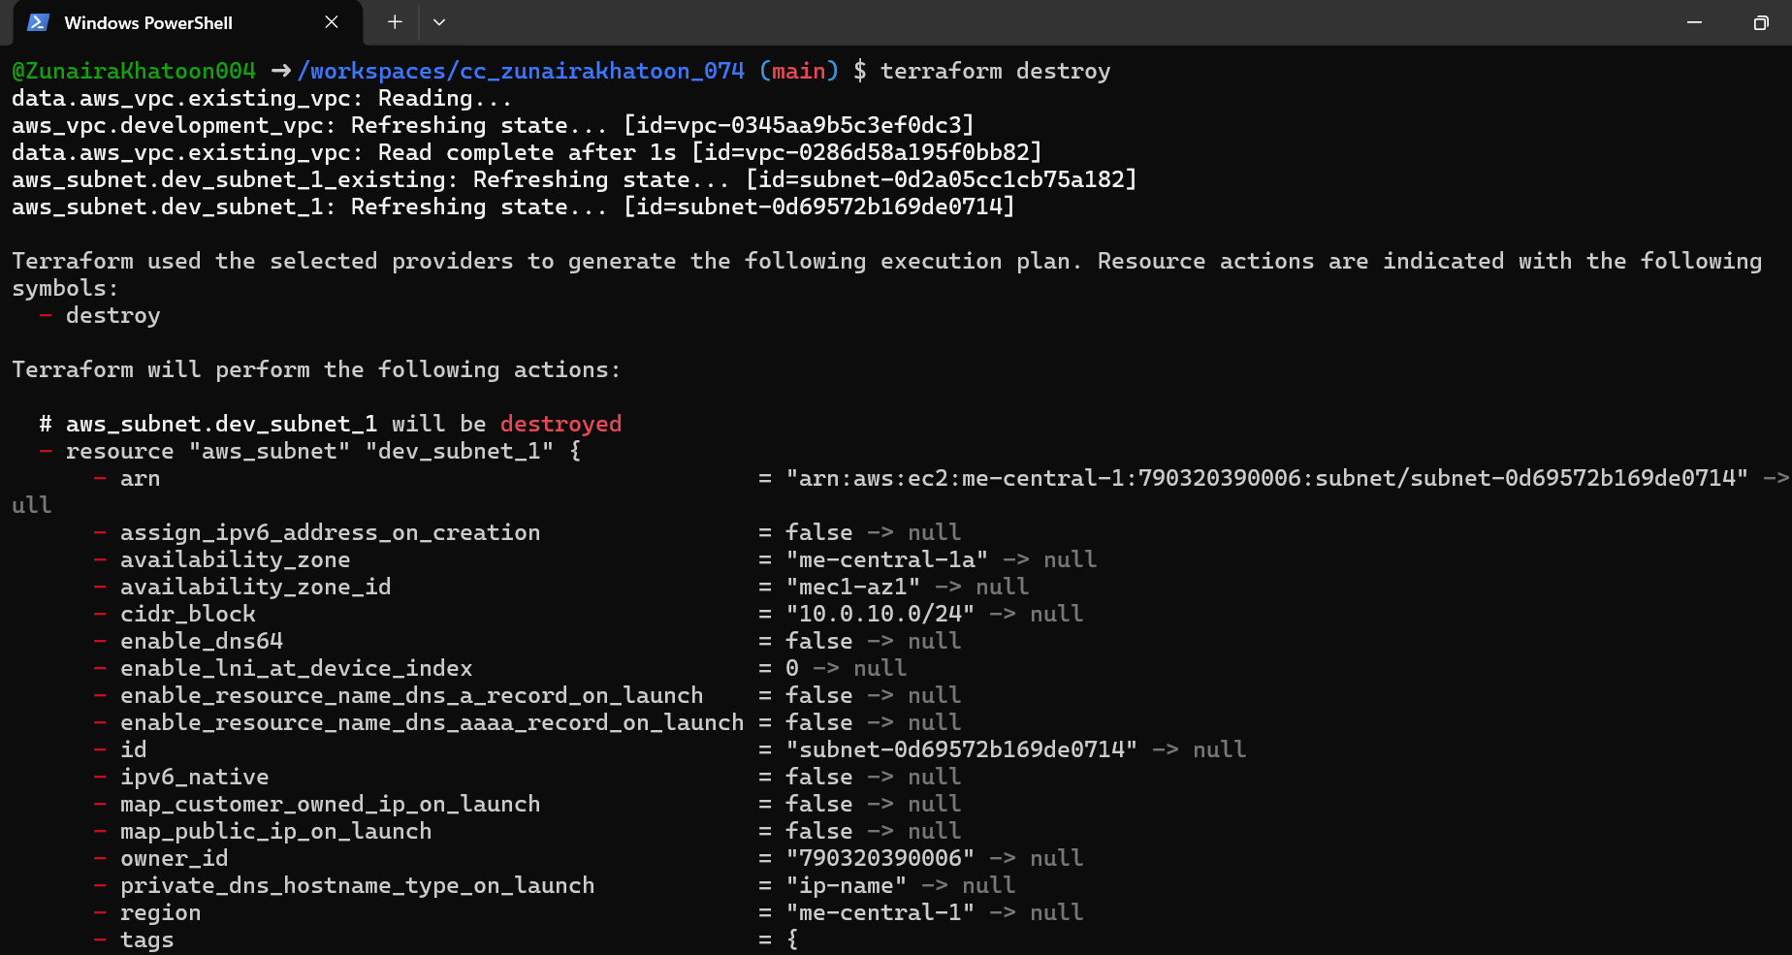

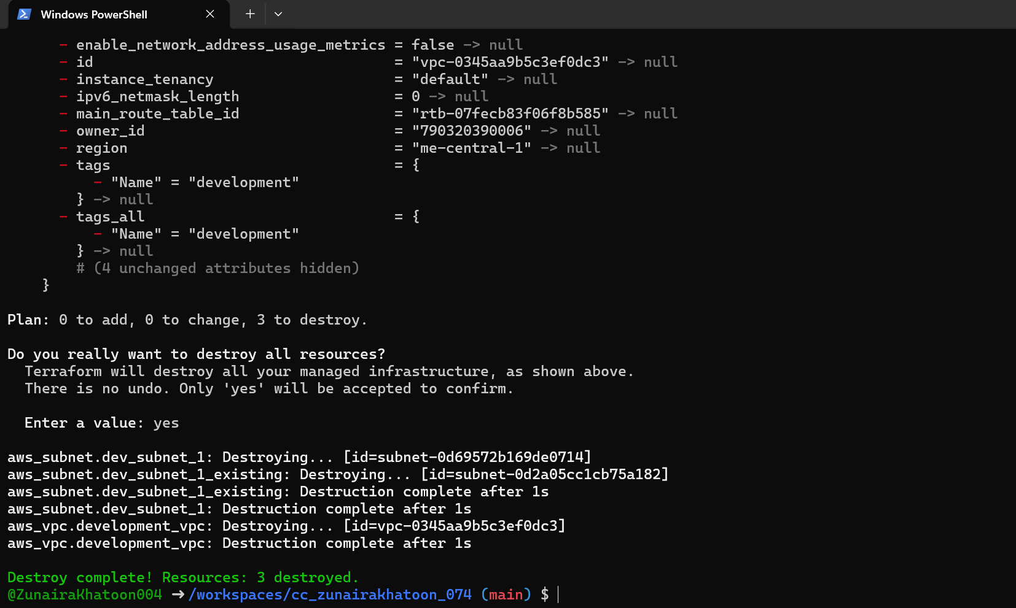

1. Inspect state files after destroy:

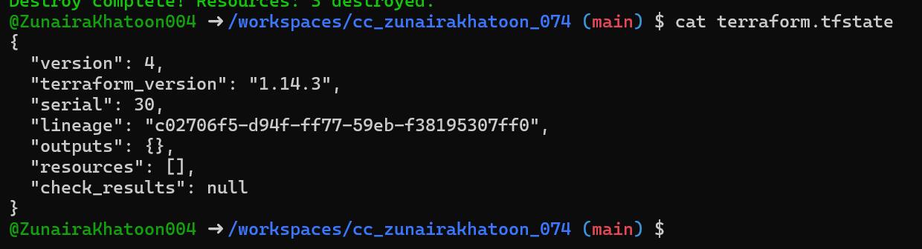

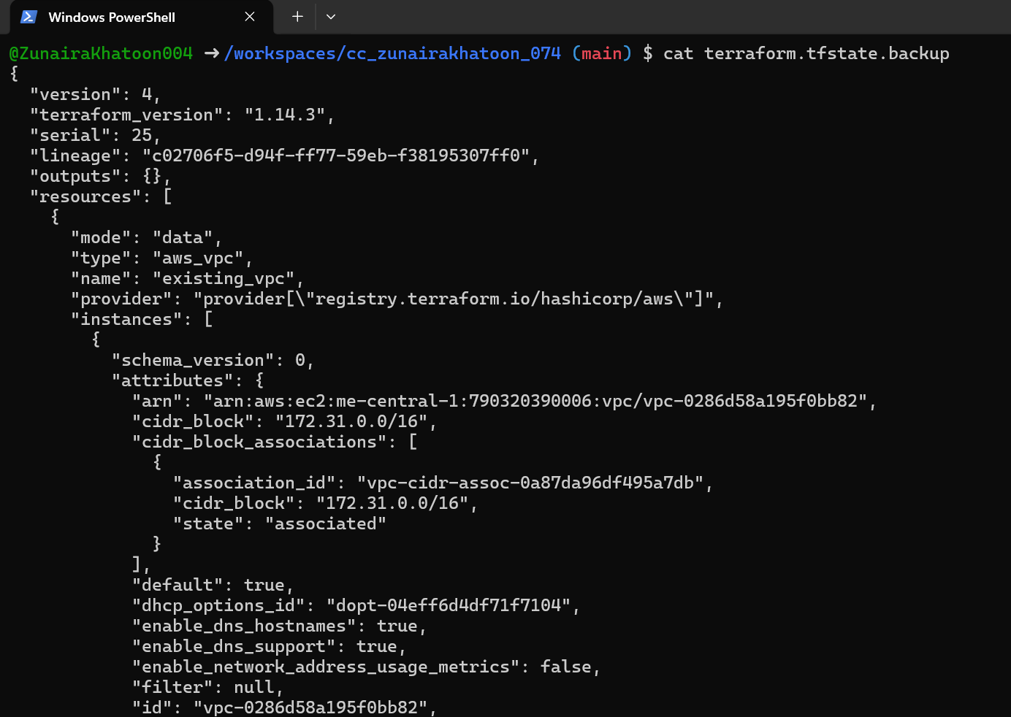

1. Recreate resources:

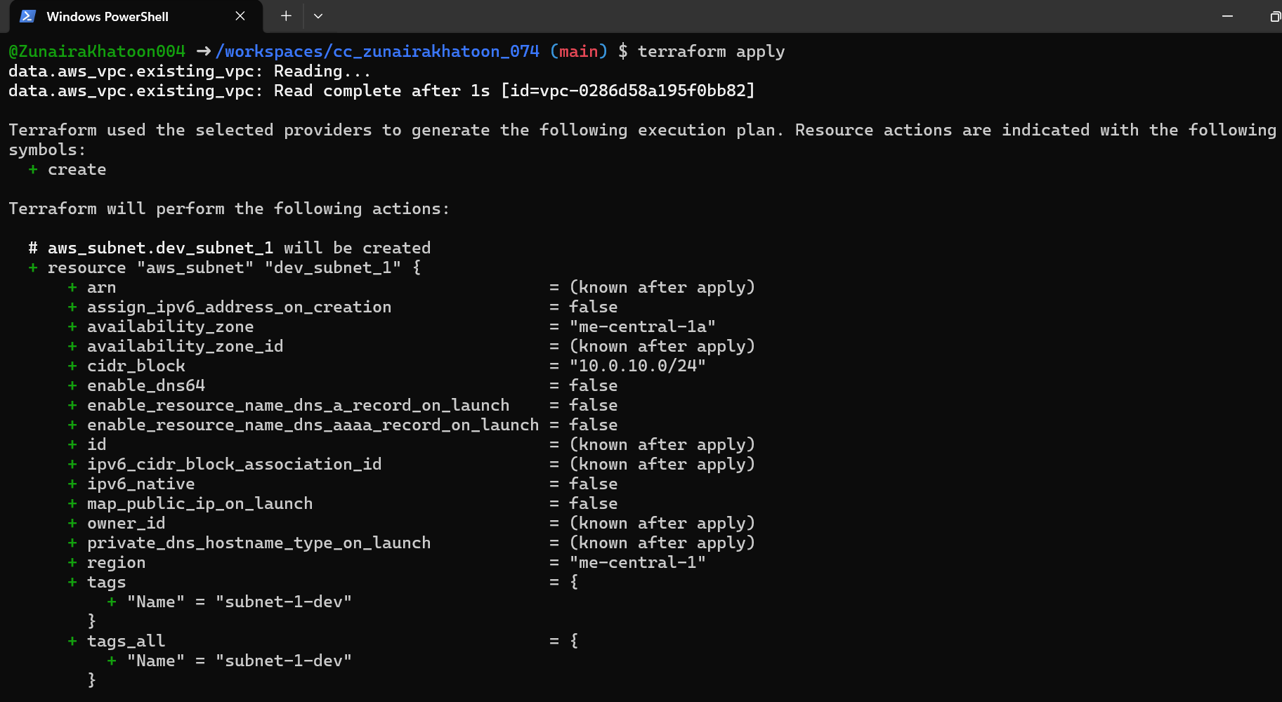

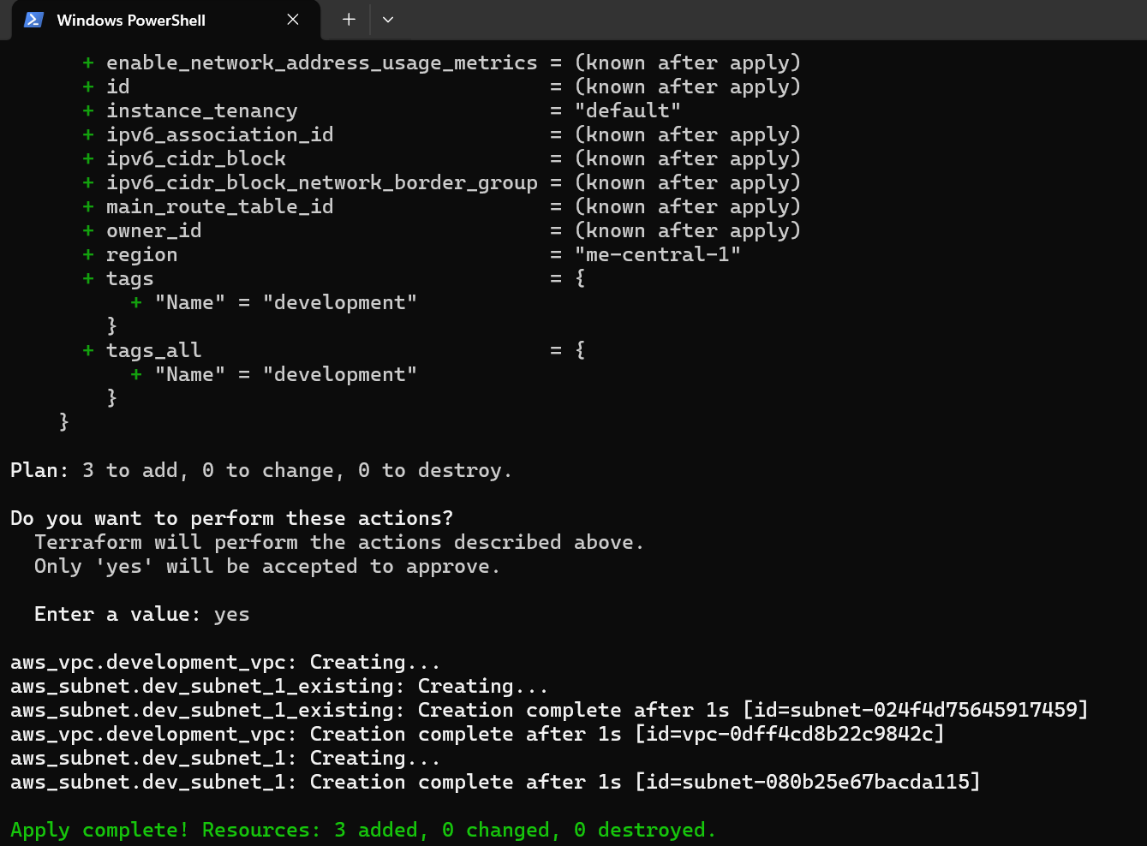

1. View state files:

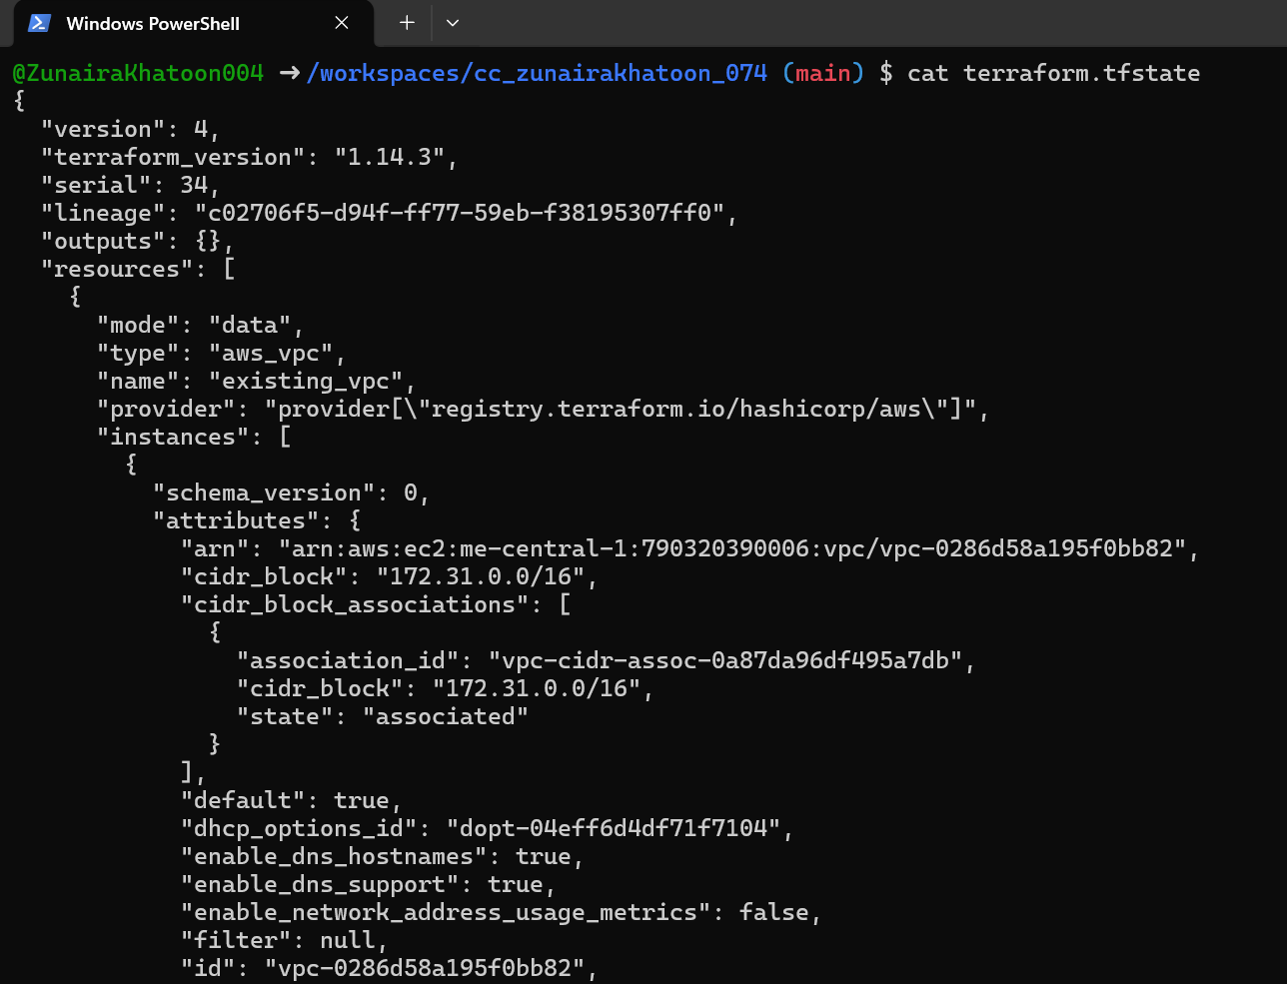

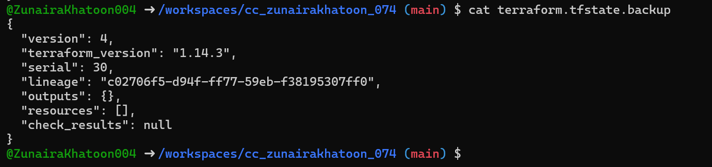

1. List resources:

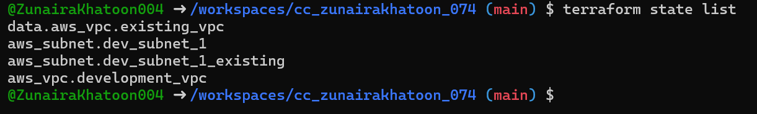

1. Show full attributes:

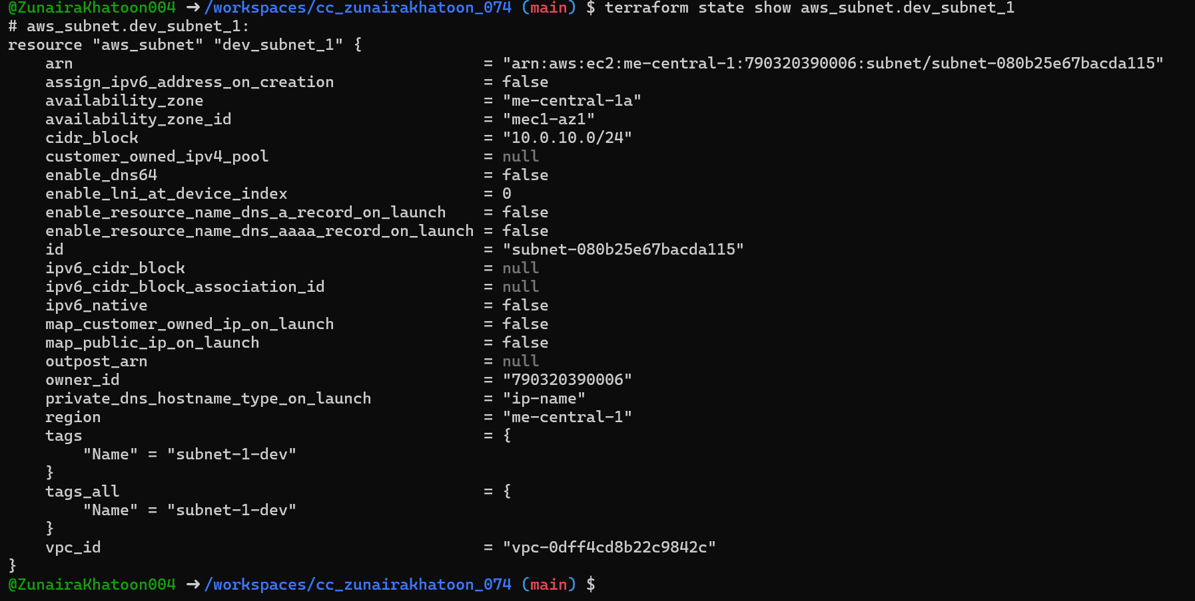

# [**Task 6: Terraform output blocks: return values (id, arn, attributes)**](https://github.com/WaqasSaleem97/CC_F25/tree/main/Lab_Tasks/Lab_10#task-6--terraform-outputs--attributes-reporting)

1. Add outputs in main.tf:

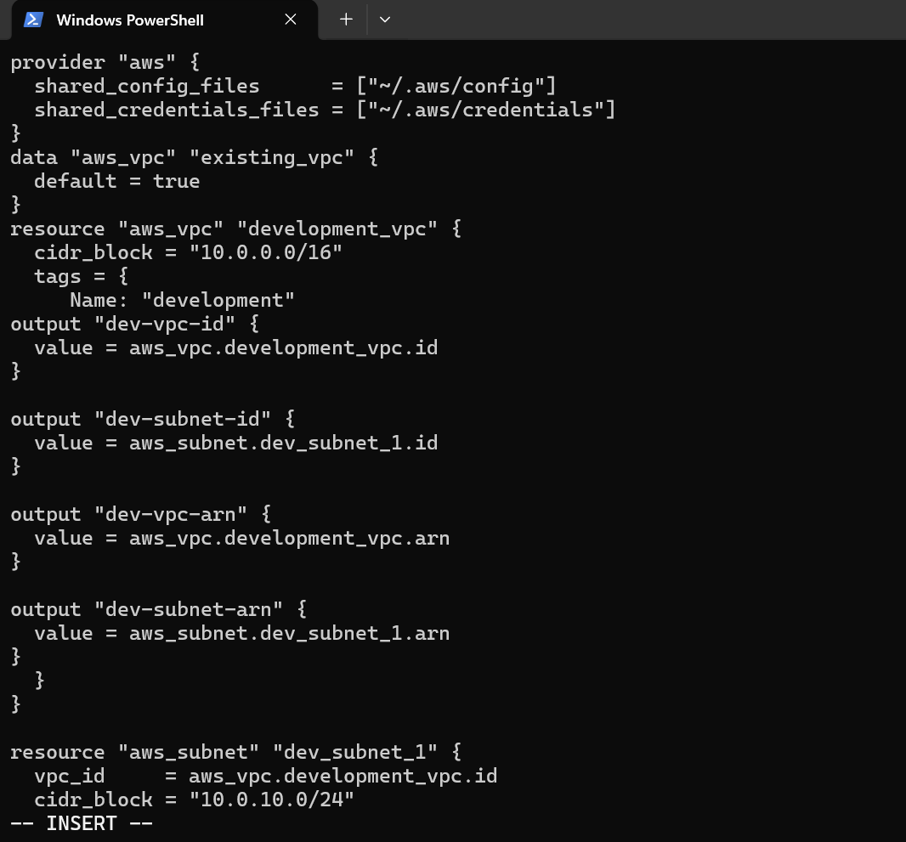

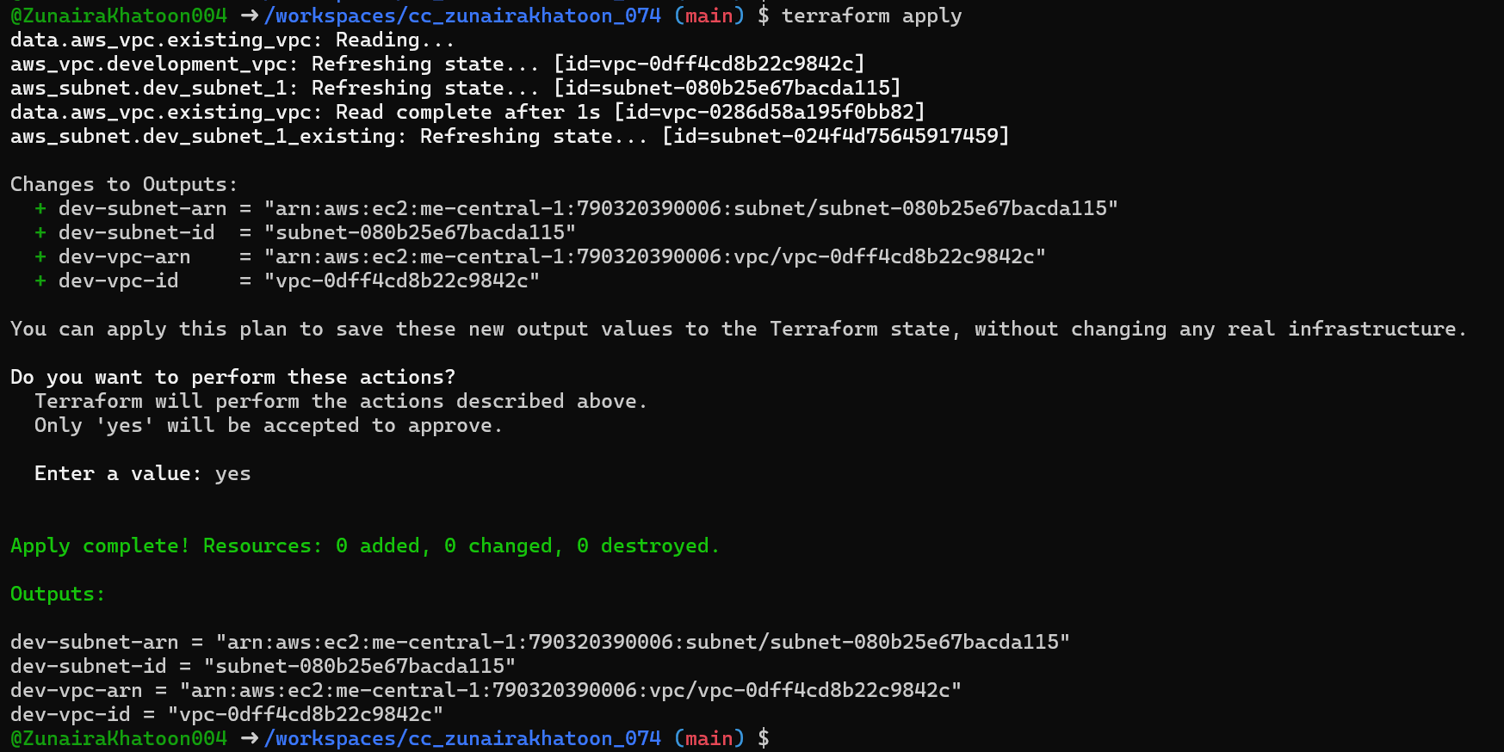

1. **Return ALL of the following output attributes from your VPC and Subnet resources:**

a) cidr_block

b) region

c) tags.Name

d) tags_all

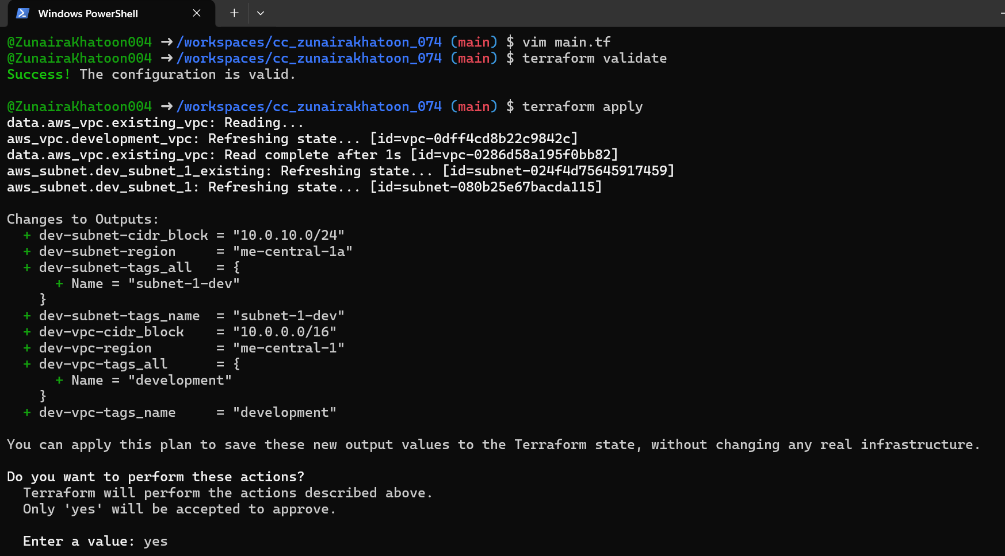

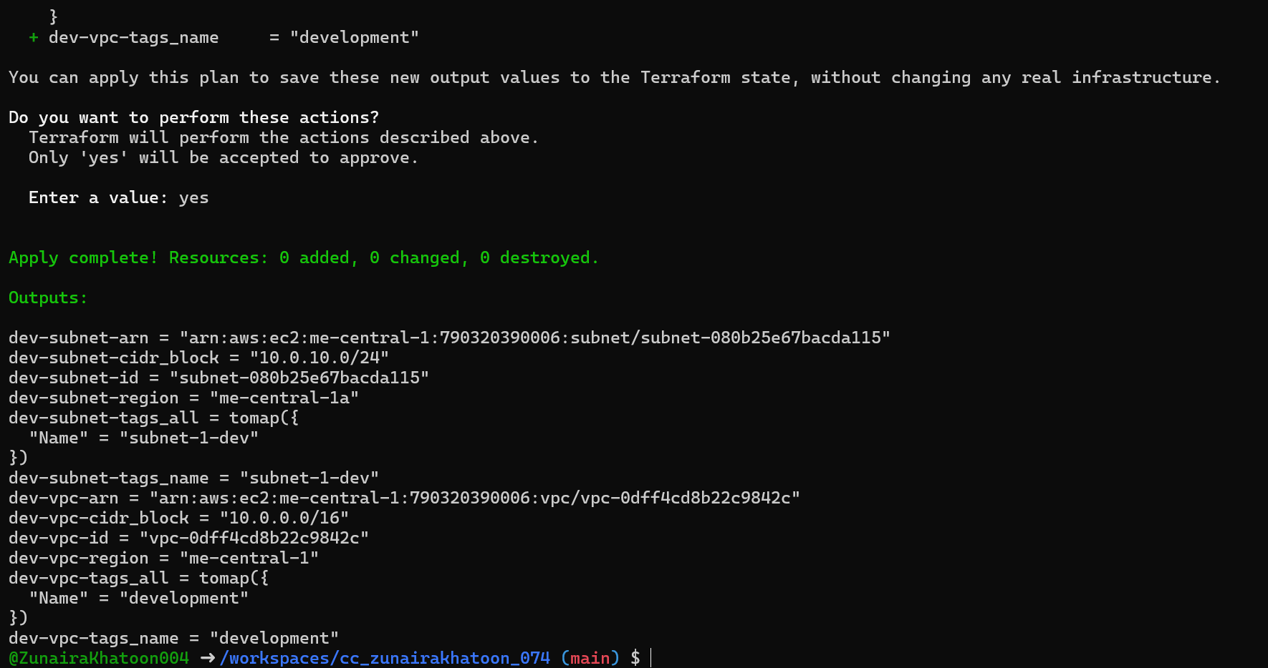

# [**Cleanup: Remove all resources, inspect state files**](https://github.com/WaqasSaleem97/CC_F25/tree/main/Lab_Tasks/Lab_10#cleanup--delete-resources-state-verification)

1. Destroy all resources:

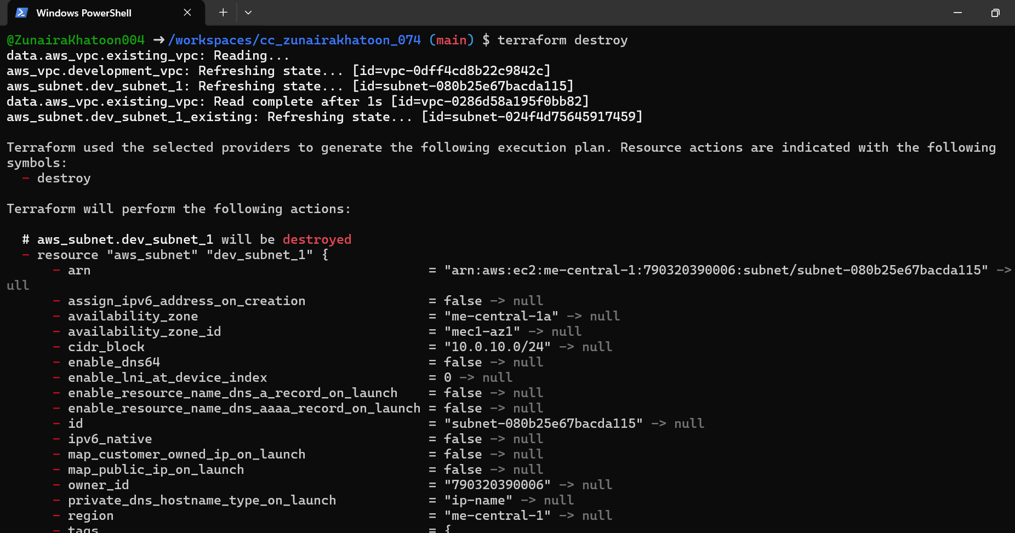

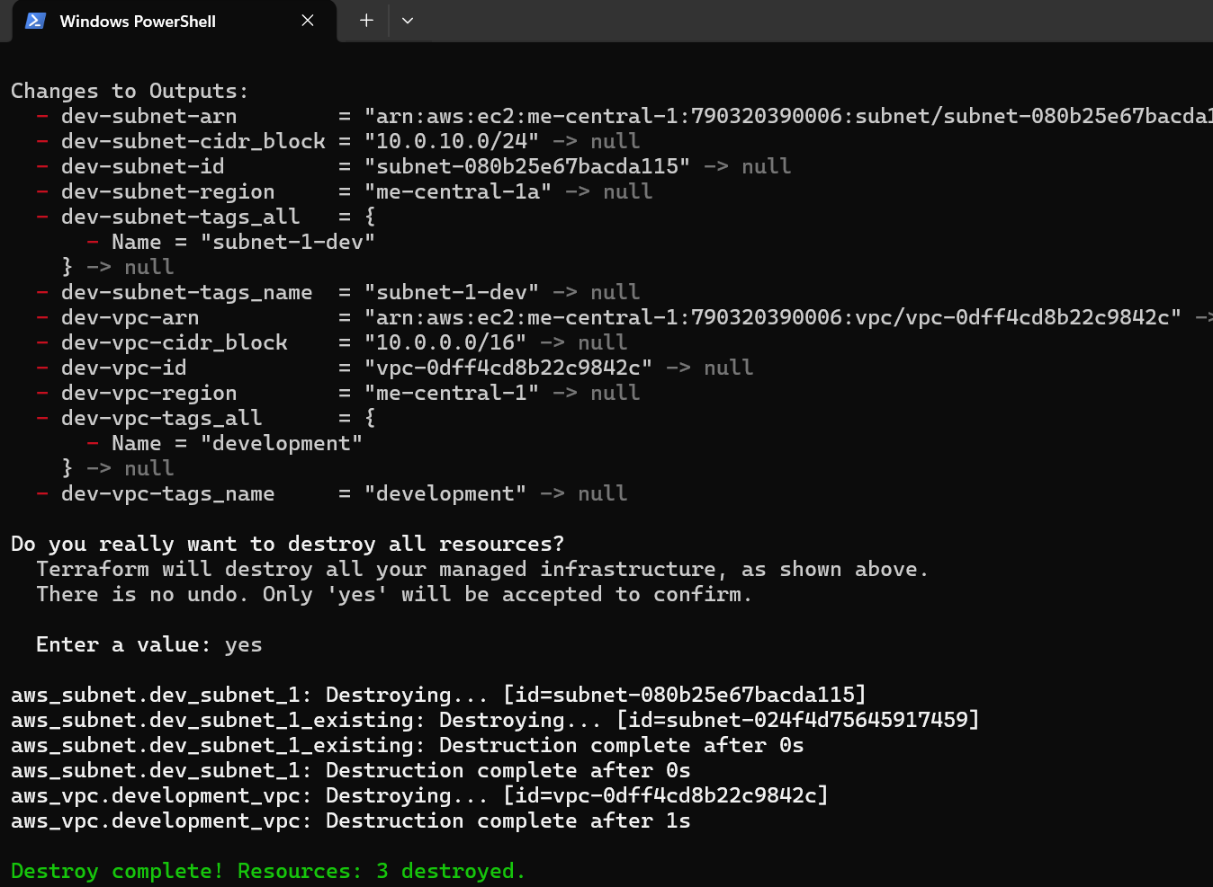

1. Inspect state files:

